Total usage time of electrical appliances：

Next, we will discuss the relationship between the total usage time of each appliance in the data set. After obtaining this information, we can correlate this with the average service life of different appliances, and finally determine whether a specific appliance has reached the established Life, so as better to provide blackwood staff with electrical maintenance and testing information.

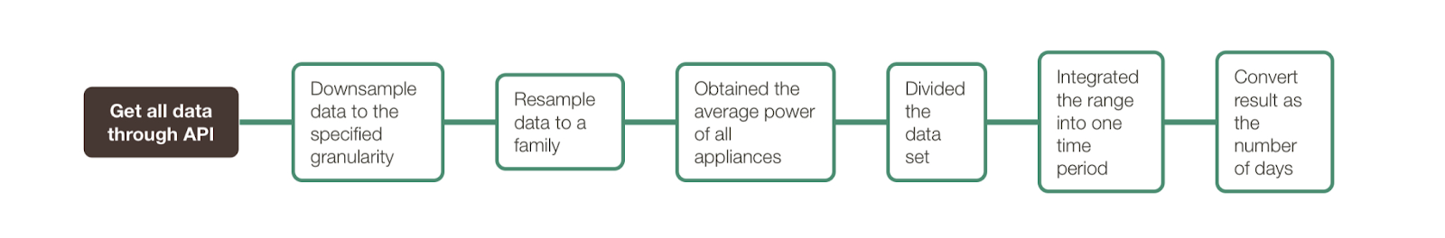

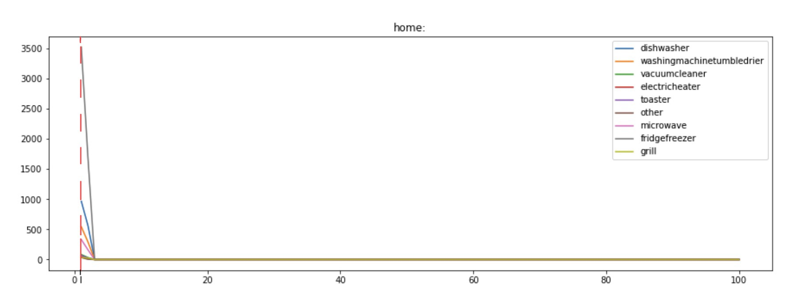

As mentioned earlier, we resample the data set, sampling all the data of a family. Then we obtained the average power of all appliances, and divided the data set into 100 time periods for processing, integrated the range into one time period for data stacking, and finally obtained the total usage time.

In the subsequent analysis, we will also convert the result in seconds as the number of days, and finally, get the proportional relationship with service life and visualize.